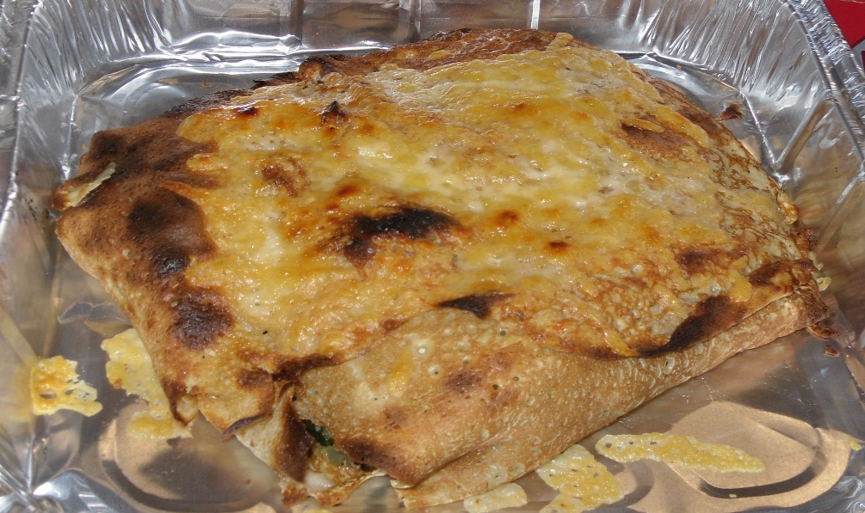

Spanakopita – Abundant Borders style
Ingredients
125 mls veg oil
2 large chopped onions
575 gms spinach
2 tablespoons chopped dill (or other garden herbs)
2 tblsps plain flour
225 gs feta cheese (or other cheese)
4 eggs lightly beaten
8 x 6” thin pancakes)
335 gms melted butter (if using filo)

Method:
- preheat oven 180c/gas 4
- fry onions in oil until softened and translucent
- add spinach, flour and dill cook on med heat until moisture absorbed
- remove from heat and allow to cool slightly
- add beaten egg and crumbled feta cheese
- grease cake tin layer pancakes alternately with spinach mixture
- finish with pancake
- cook for 30 mins in oven
- remove from oven and allow to set for three minutes
- cut into portions and serve with salad

www.abundantborders.org.uk : robin@abundsantborders.org.uk

