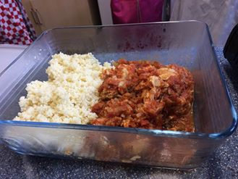
Meat (Fish Balls) in Tomato Sauce
Ingredients:
½ lb lean mince or fish
1lb onions
2-3 cloves of garlic
Herbs to taste
400 gms chopped tinned tomatoes
2 tblesp olive oil
250 gms long grain rice

Method:
- Wash rice and put on to boil
- When at full boil, stir in figure eight and then turn down heat as low as possible
- When all water absorbed approx. 20 mins stir again and leave.
- Whilst rice is cooking chop onion into small dice
- Combine half of chopped onion with mince (or fish)
- Take spoonfuls of mix and form into ping pong size balls
- Gently fry remaining onions and garlic until softened
- Add tomatoes and herbs cook for approx. 8 mins until thickened
- Add balls using spoon to drop into sauce
- Cook on fast simmer
- Add milk or water if drying too quickly

DO NOT STIR SHAKE PAN IF NEEDED

These balls do not have any cereal or binder, the trick is to ensure balls are tightly compressed when forming

www.abundantborders.org.uk : robin@abundantborders.org.uk

