FREE TRAINING |  |  | - LEARN TO GROW FOOD &  - Create a  - FOOD GARDEN
FREE TRAINING with ABUNDANT BORDERS  We are working to create a network of local food production in the Scottish Borders and, with the support of the Salvation Army, Awards 4 All and the People’s Postcode Lottery, we are offering FREE training places in Hawick.  Starting Tuesday 24th April and running EVERY TUESDAY until 3rd July, the course will help you learn how to grow fresh fruit and vegetables and create a fabulous food garden behind the Salvation Army Community Store, High Street.  Only 15 places available so contact Karen asap to book a place. |  |  | 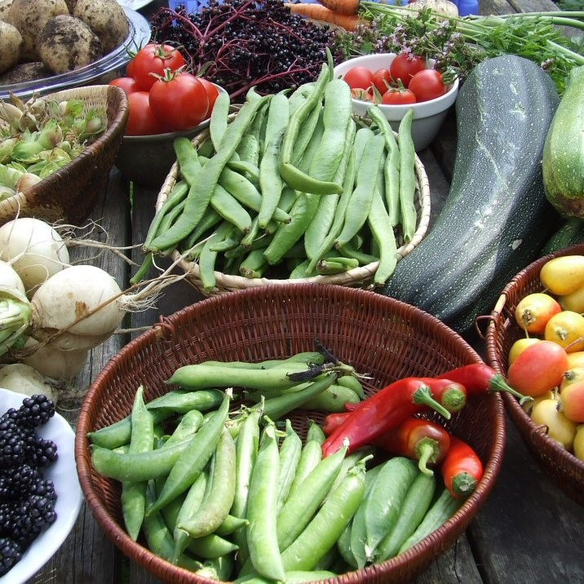  All Equipment Provided  No previous experience necessary  Contact: Karen via email  robin@abundantborders.org.uk  Telephone: 07885 905090  www.abundantborders.org.uk

