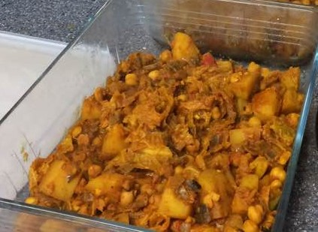
Potato and Chick Pea Curry
Ingredients:
2 large potatoes, cubed
1 large onion, chopped
1 clove of garlic, chopped
400 gms tin chick peas
400 gms chopped tinned tomatoes
2 tblesp olive oil
1 tsp cumin
1 tbsp garam masala

Method:
- Cut potatoes into bite size cubes
- Boil until just soft
- Chop onion and fry in oil and spices and chopped garlic
- When onion soft, add potatoes, chick peas and tomotoes
- Bring to the boil and simmer to reduce until tomato juice coats the potatoes, chick peas and onions
- Serve (with flatbread or rice)

www.abundantborders.org.uk : robin@abundantborders.org.uk

