IRISH BROTH |  | 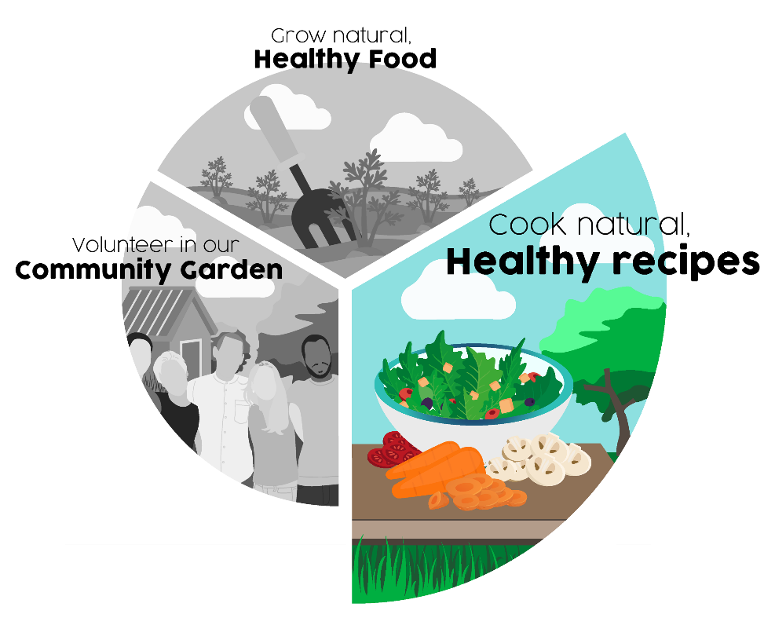
Ingredients:
- 4 oz of dried broth mix
- 1lb potatoes
- 1lb mixed root vegetables (eg. carrot,parsnip,swede) Veggies should be cut into cubes or small pieces
- 1 large onion - chopped.
- 2 pints of stock - made with stock cube
- Oil to fry
- Herbs to taste
Method:
- Fry the onions until softened
- Add cubed vegetables, gently mix together
- Add the broth mix
- Add stock
- Add herbs to taste
- Bring to the boil and then reduce to gentle simmer
- Cook until vegetables and the broth mix have softened. This usually takes about half an hour

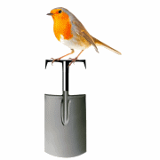 | Abundant Borders (SC049008)  web - abundantborders.org.uk & facebook.com/abundantborders  contact: robin@abundantborders.org.uk

