SPANAKOPITA |  | 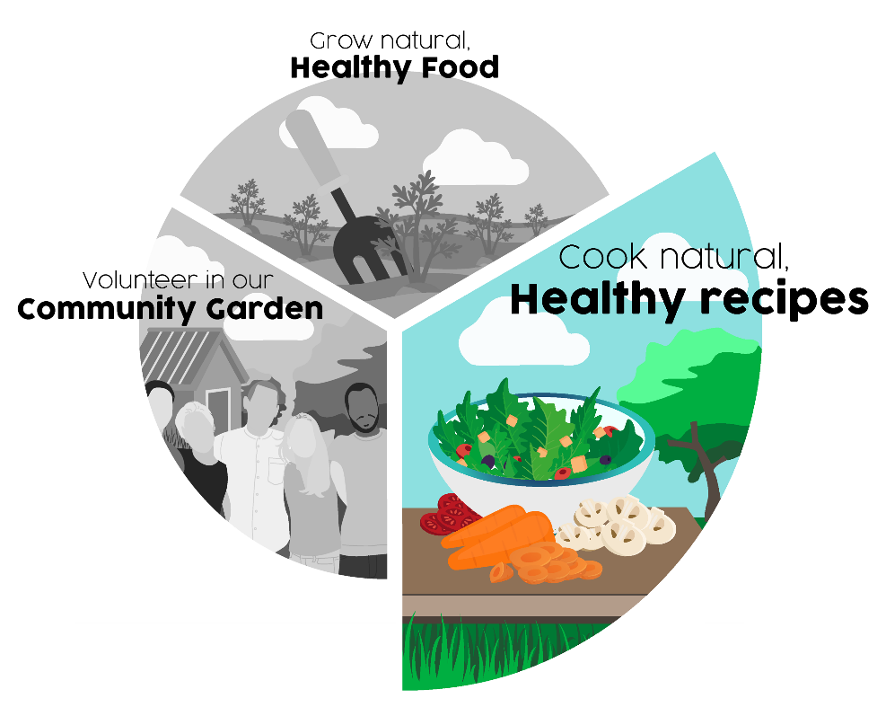
Ingredients:
- 125 mls vegetable oil
- 2 large onions – chopped
- 575 grams spinach
- 2 tablespoons chopped dill (or other garden herbs)
- 2 tablespoons plain flour
- 225 grams feta cheese (or other cheese)
- 4 eggs – lightly beaten
- 8 x 6 inch pancakes – made quite thin
Method:
- Preheat oven 180c/gas 4
- Fry onions in oil until softened and translucent
- Add spinach, flour and dill cook on med heat until moisture absorbed
- Remove from heat and allow to cool slightly
- Add beaten egg and crumbled feta cheese
- Grease cake tin layer pancakes alternately with spinach mixture
- Finish with pancake
- Cook for 30 mins in oven
- Remove from oven and allow to set for three minutes
- Cut into portions and serve with salad
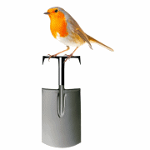 | Abundant Borders (SC049008)  web - abundantborders.org.uk & facebook.com/abundantborders  contact: robin@abundantborders.org.uk

