ELDERFLOWER
CORDIAL
Ingredients:
- 4lb sugar
- 2 pints of boiling water
- 2-3oz Citric Acid
- 2 lemons
- 20 Elderflower heads (shaken to remove any insects)
Method:
- Add the sugar to the boiling water
- Add the citric acid
- Add the grated rind of the lemon
- Slice the lemon and add the slices
- Stir until the liquid clears
- Add the Elderflower heads
- Cover and leave overnight
- Strain and bottle

The recipe does use quite a lot of sugar but it does make a good amount of syrup which is then diluted (around 1:8 ) to make a refreshing drink, so still better than cans of fizzy drink! Ice cold sparkling water, or soda water, work particularly well with the syrup. The syrup can also be used to flavour other dishes.

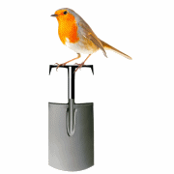 | Abundant Borders (SC049008)  web - abundantborders.org.uk & facebook.com/abundantborders  contact: robin@abundantborders.org.uk

