HEALTHIER PIZZA |  | 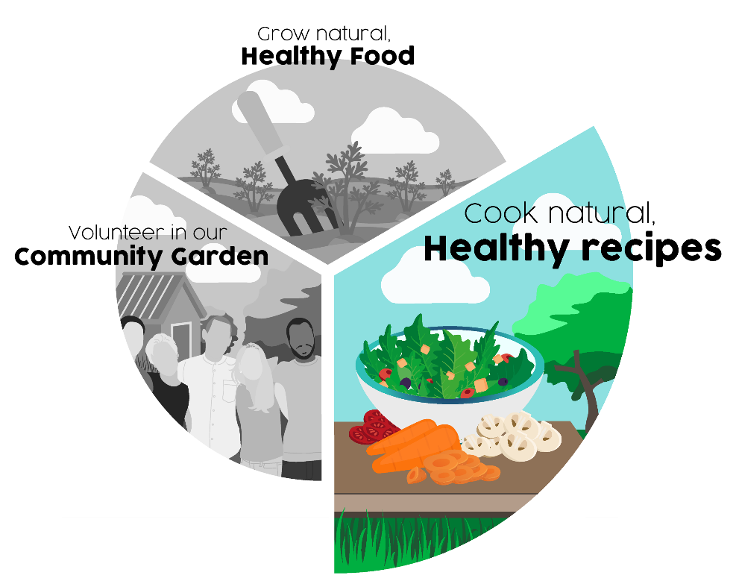
Ingredients:
for the Pizza Base
- 200 gms strong bread flour
- ½ teaspoon fast acting dried yeast
- ¼ tsp caster sugar
- A little oil for greasing
For the topping:
- 4 tablespoons olive oil – plus extra for greasing the pan
- 1 clove garlic
- 200 tinned tomatoes, well chopped
- Your choice of topping eg spinach, peppers, courgettes
- A little cheese
- Handful of fresh herbs

Method:
- Put the base ingredients into a bowl and add up to 125 mls of warm water, mix to pliable dough,
- Turn onto floured board and knead until smooth, put back in the bowl
- Cover with clingfilm and leave in warm place to double in size
- Heat 1 tablespoon oil in a frying pan, add chopped garlic and cook to soften
- Add tomatoes, and let bubble with low heat for few minutes until thickened
- Slice the vegetables thinly for the topping
- Take the risen dough out onto floured board and roll out to the right size to fit your frying pan
- Gently heat 1 tablespoon of oil in pan to grease
- Lift the dough and gently lay it in the pan
- Cook over low to medium heat until golden brown underneath and the sides start lifting away from the pan
- CAREFULLY flip over and cook for a further 2-3 mins
- Spread the tomato sauce over pizza, add your choice of toppings
- Warm through, serve and enjoy

Abundant Borders (SC049008)
web - abundantborders.org.uk & facebook.com/abundantborders
contact: robin@abundantborders.org.uk

