POTATO CURRY |  | 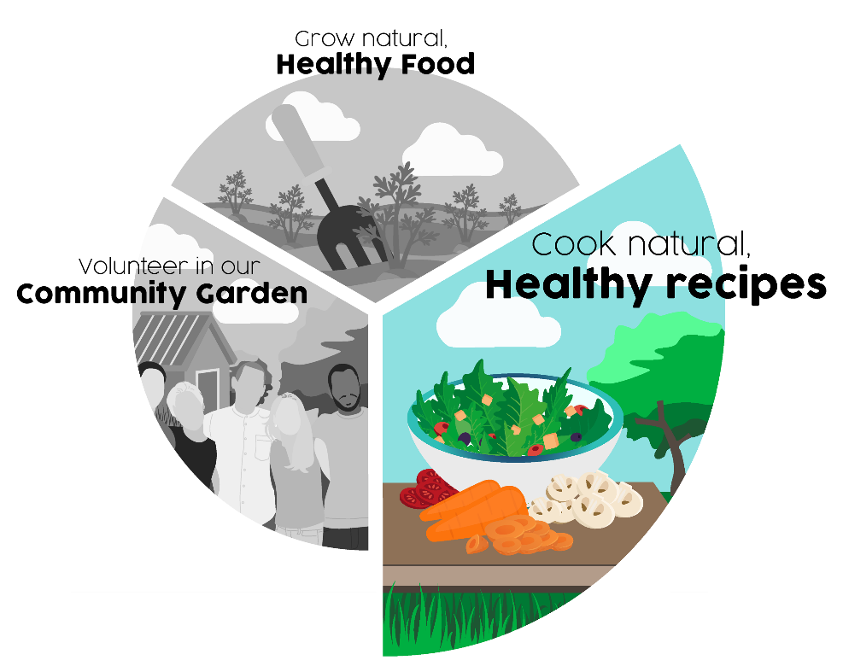
Ingredients:
- 2 large potatoes, cubed
- 1 large onion, chopped
- 1 clove of garlic, chopped
- One tin chick peas
- large tin of chopped tinned tomatoes
- 2 tablespoon of olive oil
- Curry spices – 1 tsp cumin and a tablespoon of garam masala

Method:
- Cut the potatoes into bite size cubes
- Boil until just soft
- Chop the onion and fry in oil and spices with the chopped garlic
- When onion is soft, add the potatoes, chick peas and tomatoes
- Bring to the boil and simmer to reduce the liquid – until the tomato juice coats the potatoes, chick peas and onions
- Serve (with flatbread or rice)

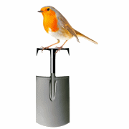 | Abundant Borders (SC049008)  web - abundantborders.org.uk & facebook.com/abundantborders  contact: robin@abundantborders.org.uk

