SINGAPORE STYLE
NOODLES
Ingredients:
- 1 packet of noodles (fine or medium egg noodles or rice noodles)
- 6 oz sliced vegetables (eg green beans, broccoli, peas, cauliflower, carrots)
- ½ large onion – sliced
- 2/3 cloves of chopped garlic
- 1 green chilli sliced finely
- oil for stir frying
- vegetable stock cube

Method:
- Soften the noodles in hot vegetable stock (made with the stock cube)
- Add 1 tablespoon of oil to a frying pan (or a wok if you have one) and heat until hot (CAREFUL!)
- Add the onions, chilli and garlic and stir fry for 1 min
- Add the sliced vegetables, starting with harder vegetables, eg carrots
- Stir continuously until vegetables cooked but still crunchy
- Add noodles which by now will have absorbed the stock
- Mix thoroughly and eat and enjoy
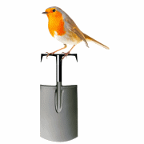 | Abundant Borders (SC049008)  web - abundantborders.org.uk & facebook.com/abundantborders  contact: robin@abundantborders.org.uk

