SODA BREAD
Ingredients:
- 170 grams of self-raising, wholemeal flour
- 170 grams of plain flour
- ½ teaspoon of salt
- ½ teaspoon of bicarbonate of soda
- ½ pint of sour milk
Method:
- Preheat the oven to 400F/220C/Gas 6
- Tip both flours, salt and bicarbonate of soda into a large mixing bowl. Stir
- Make a well in the centre and pour in the milk
- Mix quickly with a fork to form a soft dough
- Turn onto a lightly floured surface and knead briefly
- Form into a ball and flatten slightly
- Place on a lightly floured baking sheet
- Cut a cross in the top and bake for about 30 minutes – until the loaf sounds hollow when tapped
- Cool on a wire rack

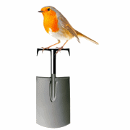 | Abundant Borders (SC049008)  web - abundantborders.org.uk & facebook.com/abundantborders  contact: robin@abundantborders.org.uk

