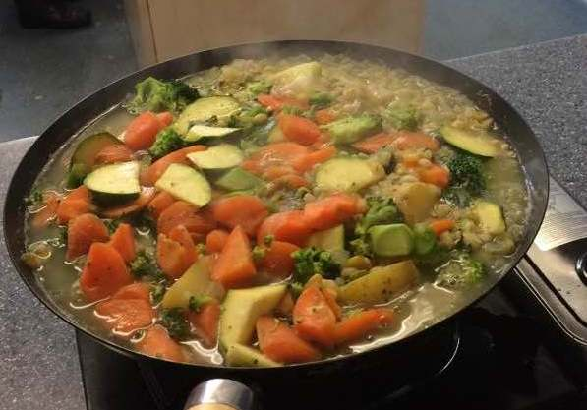

Irish Broth
Ingredients
4 oz broth mix
1lb potatoes
1lb mix root vegetables (i.e. carrot,parsnip,swede)
1 large onion
2 pints of stock made with stock cube
Oil to fry
Dry herbs to taste

Method:
- Fry onions until softened in oil
- Add cubed vegetables, gently mix together
- Add rinsed broth mix
- Add stock and herbs to taste
- Bring to boil and then reduce to gentle simmer
- Cook until vegetables softened and broth mix softened approx. 30 mins

with Soda Bread
Ingredients
6oz self-raising wholemeal flour
6oz plain flour
½ tsp salt
½ tsp bicarbonate of soda
½ pint soured milk

Method:
- Preheat the oven to 400F/200C/Gas 6.
- Tip the flours, salt and bicarbonate of soda into a large mixing bowl and stir.
- Make a well in the centre and pour in milk, mixing quickly with a fork to form a soft dough
- Turn onto a lightly floured surface and knead briefly.
- Form into a round and flatten dough slightly before placing on a lightly floured baking sheet.
- Cut a cross on the top and bake for about 30 mins or until loaf sounds hollow when tapped.
- Cool on a wire rack.

www.abundantborders.org.uk : robin@abundsantborders.org.uk

