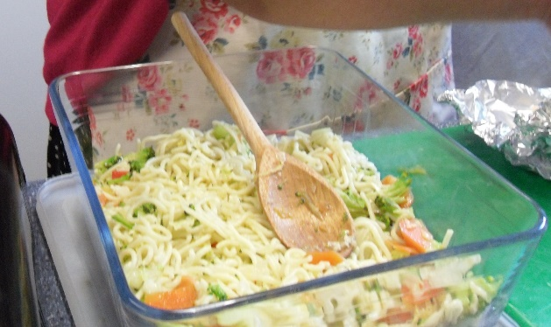

Singapore Style Noodles – the Abundant Borders way
Ingredients
1 packet of noodles (fine or medium egg noodles or rice noodles)
6 oz sliced vegetables (eg green beans, mange tout, broccoli, peas, cauliflower ,carrots)
½ large onion sliced
2/3 cloves of chopped garlic
1 green chilli sliced finely
oil for stir frying
Cup of vegetable stock

Method:
- Soften the noodles in hot vegetable stock (can be made with stock cube)
- Add 1 tablespoon of oil to the wok heat until hot
- Add onions, chilli and garlic and stir fry for 1 min
- Add sliced vegetables, starting with harder vegetables, eg carrots
- Stir continuously until vegetables cooked but still crunchy
- Add noodles which have absorbed stock, mix thoroughly

With Steamed Fish
Ingredients
1 piece of fish (per person)
2 cloves finely chopped garlic
1 green chilli
2 stems of spring onions, chopped, including green stems
2 tablespoons vegetable oil

Method
- Put fish in pan and cover with cold water
- Bring to a fast simmer,
- Take off heat and allow to cook (10 mins)
- Remove fish from water and transfer to warm serving dish
- With care, remove the skin from fish
- Sprinkle chopped ingredients over the cooked fish

www.abundantborders.org.uk : robin@abundantborders.org.uk

