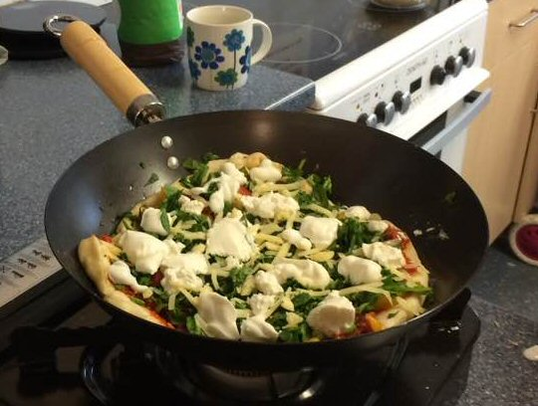
Frying Pan Pizza
Ingredients:
For base:
200 gms strong bread flour
½ teaspoon fast acting dried yeast
¼ tsp caster sugar
A little oil for greasing
For topping:
4 tablespoons olive oil plus extra for greasing
1 clove garlic
200 gms passata
Pinch of sugar
Desired veg spinach, peppers, courgettes
Ricotta and cheddar cheese
Handful of mint

Method:
- put dry ingredients into a bowl and add up to 125 mls of warm water, mix to pliable dough,
- turn onto floured board and knead until smooth, put back in bowl
- cover with clingfilm and leave in warm place to double in size
- heat 1 tblspn oil in pan, add chopped garlic and cook to soften
- add passata, season and let bubble with low heat for few minutes until thickened
- slice vegetables thinly for the topping
- take the risen dough, knock out onto floured board and roll out to fit frying pan
- gently heat 1 tablespoon of oil in pan to grease
- lift dough with rolling pin and gently lay in pan
- cook over low to medium heat until golden brown underneath and sides lifting
- flip over, drizzle little oil between pizza and pan and cook for 2-3 mins
- spread sauce over pizza, add toppings
- serve and enjoy

www.abundantborders.org.uk : robin@abundantborders.org.uk

